Best practices for crawling in SharePoint Server 2013 :

<http://technet.microsoft.com/en-us/library/dn535606(v=office.15).aspx#BKMK_CrawlUserProfiles>

**Setup for SharePoint search**

1) Extend existing web apps

-Central Admin >[Application Management](http://evadne7:17076/applications.aspx) >[Manage service applications](http://evadne7:17076/_admin/ServiceApplications.aspx) > Extend (ribbon)

-change port (ie 80 -> 802)

-check windows authentication NTLM

-ok

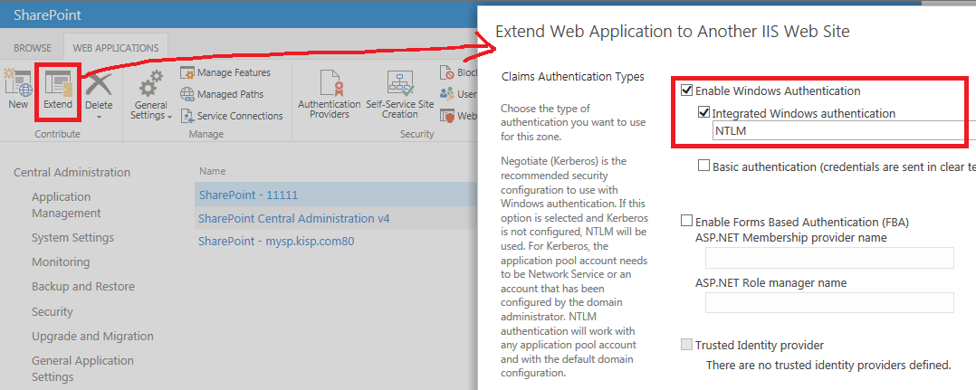

**Setup for Crawling**

If no Search Service Application then create a new one with defaults

*note* if you are creating new app pool during setup, make sure you use 2 different name for Search App Pool & Search Query App Pool.

**2) Modify content sources**

Central Admin >[Application Management](http://evadne7:17076/applications.aspx) >[Manage service applications](http://evadne7:17076/_admin/ServiceApplications.aspx) >Search Service Application

> Content Sources

- Edit Local SharePoint sites

- modify the start addresses

http://sp.kisp.com:802 🡨 for sp site

sps3://sp.kisp.com:802

http://mysite.kisp.com:802 🡨 for mysite

sps3://mysite.kisp.com:802

- select crawl everything

- select enable continuous crawls

- click ok

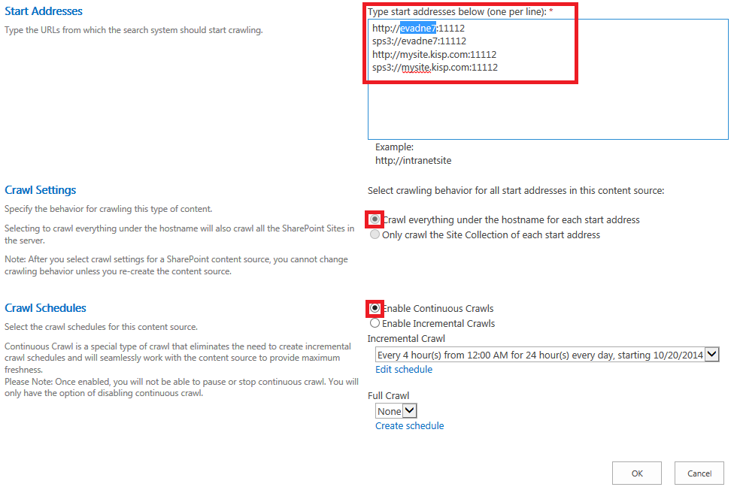

**3) add server mapping for extended web app**

Central Admin >[Application Management](http://evadne7:17076/applications.aspx) >[Manage service applications](http://evadne7:17076/_admin/ServiceApplications.aspx) >Search Service Application

> Server Name Mappings(side)

- add new mapping for each extend

ie: in my case, 11112 is extend of 11111

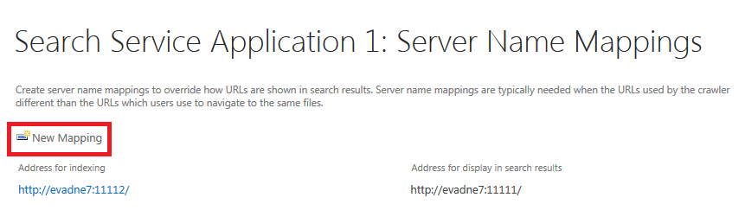

- After crawl is done you should be able to do a search now